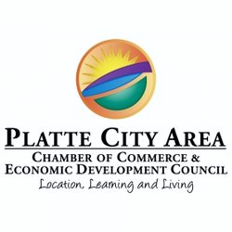
Platte City Area Chamber of Commerce
Welcome Bag Program Agreement

Business Name ___________________________________________________
Contact Name ____________________________________________________
Address ___________________________________________________________
Email Address ____________________________________________________
Phone _____________________________________________________________

I understand it is my responsibility to keep the Chamber stocked with promotional items. (15 items/month. We encourage you to provide enough items to last through December.)

So we can get to know your business better, please give us your elevator speech!
_________________________________________________________________________________

_________________________________________________________________________________

_________________________________________________________________________________

_________________________________________________________________________________

Participant agrees to pay Platte City Area Chamber of Commerce a yearly fee of $300, prorated based on agreement date. Participation in the Welcome Bag Program will begin on the first day of the month following a one-time payment for the year/remainder of year. Participation will automatically renew on January 1st unless member notifies Chamber in written form by December 15th of the year prior to the next renewal date.
The Chamber will reach out to all new residents and new businesses of the Platte City area and PCR-III school district, within 60 days of arrival.
**BONUS: Signup by April 1st to get your company logo displayed on each reusable bag at no extra charge!**

Participant Signature ________________________________________________ Date ____________

Chamber Representative ____________________________________________ Date _____________

Platte City Chamber of Commerce/EDC 620 Third Street, P.O. Box 650, Platte City MO 64079 Ph: 816.858.5270

